Continuity Book Template

Table of Contents
Duties and Responsibilities 3
Organization Chart 4
Points of Contact 5
References 6
Tasks 7
Calendar of Events 8
Maps and Locations 9
Equipment List 10
Onboarding Checklist 11
Lessons Learned 12

Continuity Book FAQs
What is a continuity book?
Whether you are out on leave for a week, transitioning to a new job, or retiring, a continuity book is a great way to pass relevant information to your successor or anyone standing in for you. This template is meant as a guide for you to document your processes, activities, and other important knowledge specific to your position. Helping others continue your work at NASA is one way to continue your legacy and help those who follow in your footsteps!
What format should the continuity book be in?
One size does not fit all- the best format is the one that will actually get used and can be passed along. Some options include:
- Physical Binder: Print everything out and store in a binder with sections. This may be a great desk reference, or an easy way to "hand over" the binder to a new employee (especially when they are figuring out how to navigate online resources).
- Electronic Method: Use a Share Drive, SharePoint, or One Note to create folders and sections. Then include files, documents, videos, and links as appropriate. This is a great method for remote work, large files, and frequent updates.
When should I make a continuity book?
The best time to create a continuity book is when you are first starting in your position. When you are new to a position, you are actively gathering all the information that is needed for a continuity book already. Just keep it organized in a continuity book from the start, and update along the way. Your successor will thank you! If someone has already passed you a continuity book, be sure to validate its contents and update it as required.
Do I have to follow this guide exactly?
No! This is just a start. All jobs and positions are different. Modify this template as required to fit your needs. Add or delete sections. Don’t have to start from scratch- add links to online resources or simply refer to other documents that have already been created. It’s all about having an easy way to find relevant information.

Duties and Responsibilities
List your overall duties and responsibilities. This may be a simple description of your job or a longer list of programs or projects that you participate in and your responsibilities to that program or project.

Organization Chart
Insert any organization charts for reference. Example:
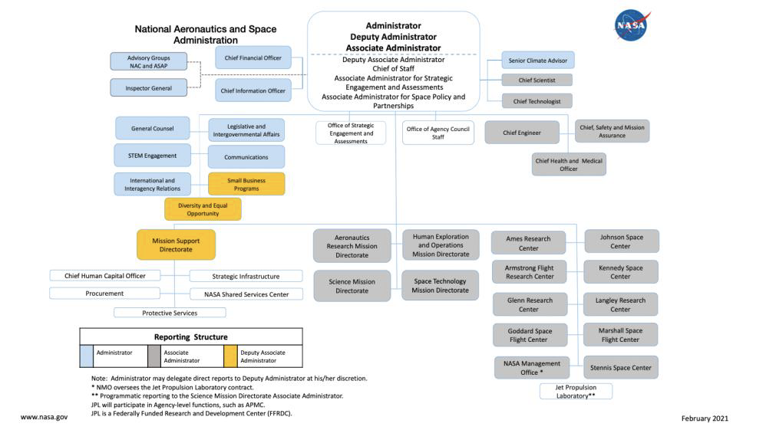

Points of Contact
List any points of contact, their roles, and how to contact them. Other relevant information may include the best day/time to contact them. You may also include communities of practice to join.
Name | Position | Phone # | Email | Notes
Ex. Jane Doe | Center Knowledge Officer | 123-456-7890 | Jane.Doe@nasa.gov | Best person to contact if needing to develop a knowledge management program

References
List any frequency used documents, books, website, or regulations that are essential to your job. Include links or a printout. Highlight important sections. Example:
Publication/Website | Link | Notes
Continuity Checklist for Incoming Members | https://appel.nasa.gov/wp-content/uploads/2022/03/kct-incoming-member-guide.pdf | Great checklist to use when shadowing or transitioning to a new job.
APPEL KS Website | https://appel.nasa.gov/ | Great resource for knowledge management and lessons learned.

Tasks
Create a list of daily, weekly, or monthly activities. Examples include meetings to attend, reports that are due, milestones, or equipment that needs to be maintained. Include details about how to accomplish the activities. If required, add another page to include step by step instructions.

DAILY CHECKLIST

WEEKLY CHECKLIST

MONTHLY CHECKLIST

Calendar of Events
Insert calendars, lists of events, schedules, or milestone trackers.
Example:
Jan 1: New Year’s Day-Federal Holiday
Feb 10: Conference
Mar 7: Launch Readiness Review
Apr 12: Lessons Learned Event

Maps and Locations
Include maps or descriptions of any places that you travel to or buildings/rooms that you often use. Include details on how to get access to those facilities.

Equipment List
Include a list of equipment that you operate or maintain. Include printouts or links to equipment manuals, instructions, or how-to videos.

Onboarding Checklist
This is a list of things that your successor should do when onboarding. It may include everything from computer account activations, regulations to read, people to meet, or websites/programs to familiarize themselves with. You may also have a HR Onboarding Checklist to reference. Example:
- Read about knowledge capture and transfer: https://appel.nasa.gov/knowledge-capture-and-transfer/
- Review NASA lessons learned: https://appel.nasa.gov/knowledge/results/?_knowledge_category=lessons-learned.
- Schedule sit down with supervisor to discuss expectations.
- Review the APPEL PM & SE Career Development Framework and sign up for APPEL-KS courses: https://appel.nasa.gov/career-development/development-framework/.

Lessons Learned
List any lessons learned, advice, or things you learned to “hard way” to pass on. Organize by theme or project. You may also include links to a lessons learned website.

